*Innovative agricultural engineering receives coveted awards*

**Two silver Agritechnica Innovation Awards for CLAAS and 3A**

*Harsewinkel, November 2023. Two innovative solutions from CLAAS have scooped prizes at this year’s Agritechnica – a silver Innovation Award for the multi-dimensional linkage control system and a further silver medal for the 3A Autonomy Group. Both developments aim to further increase automation and precision in agriculture.*

CLAAS has a long tradition of Agritechnica Awards – thanks to innovative developers and practice-driven solutions designed to boost productivity and efficiency and enhance user-friendliness. This year's awards demonstrate the company’s ongoing commitment to this strategy.

**CEMOS and 3A: highly automated and autonomous work become reality**

The 3-point linkage has been around for almost 100 years – and in this time its basic operating principles have scarcely changed. Now CLAAS had developed the next generation of this key tractor-implement interface with the launch of the multi-dimensional linkage control system, which is a future expansion of CEMOS for Tractors that has earned a silver Agritechnica Innovation Award.

This is the third Innovation Award for CEMOS for Tractors technology. The system received its first silver award at Agritechnica 2017 as the first dialogue-based, self-learning operator assistance and process optimisation system for tractors. The second silver Innovation Award came at the end of 2021 for integrating the large Terranimo® database into CEMOS for Tractors. This made it possible for the first time to incorporate soil protection into CEMOS and use it with a CLAAS CTIC tyre pressure control system. Since 2022, automatic indication of the risk of soil compaction has been included as standard with CEMOS for Tractors.

Now for the first time, the award-winning multi-dimensional rear linkage integrates the hydraulic top link and implement into the linkage control system via a hydraulic spool valve. Together with implement-side sensors and ISOBUS, this allows implements from ploughs to fertiliser spreaders to be precision-guided. For example, the control system can transfer weight from a mounted cultivator to the tractor's rear axle or optimise the spread pattern of a fertiliser spreader by ensuring that it is always aligned horizontally with the ground. Quality of work improves in all application scenarios while at the same time fuel consumption is reduced by 5 to 14% during tillage work. The innovative linkage control system will extend the scope of CEMOS functions for CLAAS tractors in the medium term, supporting the resource-friendly control of tillage implements.

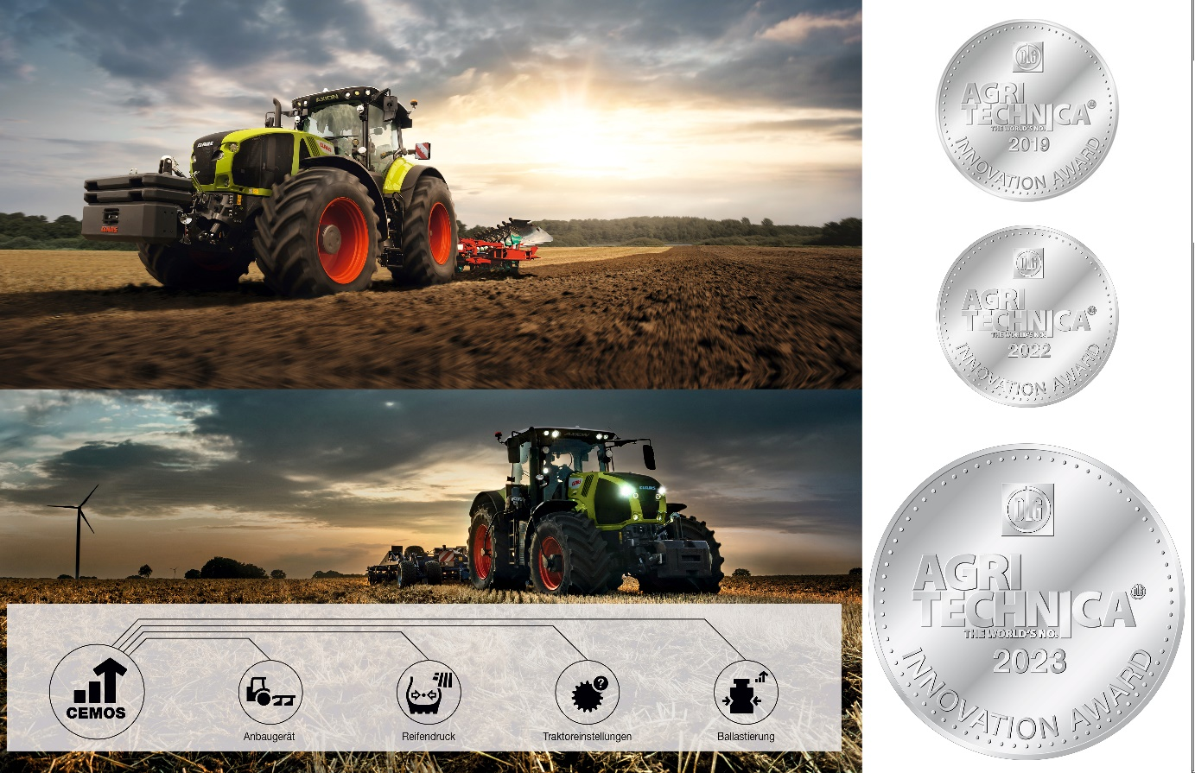

CEMOS for Tractors and associated technologies have already earned three Agritechnica Innovation Awards since its launch at Agritechnica 2019.

The 3A – ADVANCED AUTOMATION & AUTONOMY Group received a further silver medal for its open approach to advancing and developing highly automated and autonomous tractor-implement combinations for field cultivation. 3A was established in late summer 2023 by CLAAS, AgXeed and Amazone. It has now been joined by a fourth partner, Müthing, and discussions are currently underway with other agricultural machinery manufacturers.

"We are delighted to join the ranks of award winners in the run-up to the world's leading trade show for agricultural machinery", say 3A founding members CLAAS; AgXeed and Amazone. "The Group's open, multi-manufacturer approach enables smaller manufacturers with fewer development resources to share in the progressive automation of fieldwork. The advantages are obvious: the Group's combined expertise will enable technologies to reach market maturity more rapidly, speeding up standardisation in the process. Furthermore, with access to a wide range of manufacturer solutions, farmers and contractors will be able to select the technology best suited to the needs of their business."

The Group aims to accelerate and consolidate technical developments in the fields of automation and autonomy by working together to standardise interfaces and provide practical solutions to the diverse challenges of tillage automation. 3A’s first technical solutions are CLAAS Autonomy connect, AgXeed Box and Amazone AutoTill. Other machine manufacturers will be joining the Group to play an active role in expanding the range of applications for outdoor work processes.

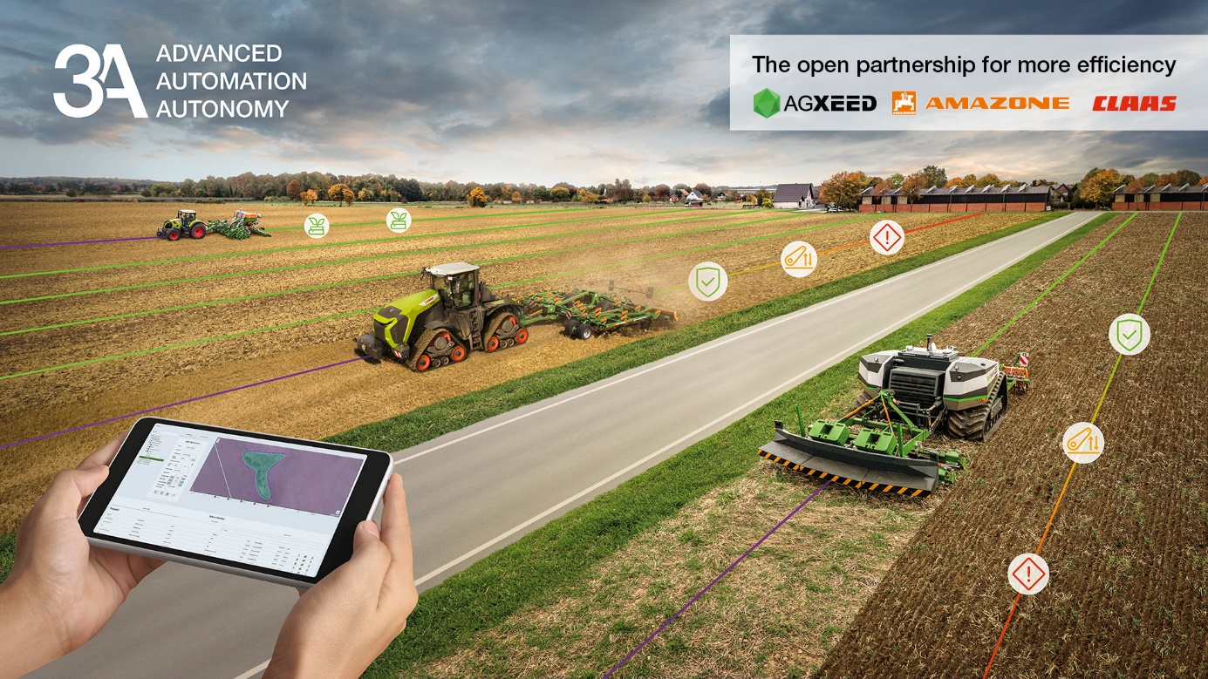

Different 3A technologies, solutions and products can be seen at the CLAAS, AgXeed and Amazone stands at Agritechnica.

***You can download high-resolution images here:***

<https://dam.claas.com/pinaccess/showpin.do?pinCode=t3fr3q06ArMd>

**Please note the following in your journalistic work:**

This is an international press release. The product range and feature options may vary in some countries. Please ask the CLAAS sales company or the CLAAS importer in your country in case of doubt.

**Press picture archive at claas-group.com**

Visit our online press photo archive. A wide range of pictures is available for use in your journalistic reports, free of charge, at: www.claas-group.com > Picture archive

***About CLAAS***

*CLAAS (*[*www.claas-gruppe.com*](http://www.claas-gruppe.com)*) is a family business founded in 1913 and is one of the world’s leading manufacturers of agricultural machinery. The company, with Head Office in Harsewinkel, Westphalia, is the European market leader for forage harvesters. CLAAS dominates the European market in another core segment as well – combine harvesters. CLAAS also holds the top spots in global agricultural technology with its tractors as well as its agricultural balers and grassland harvesting machines. Cutting-edge agricultural information technology also forms part of its product range. CLAAS employs more than 12,000 staff worldwide and generated a turnover of 4.9 billion euros in 2021.*